Cinémathèque Stage Plot / Input List
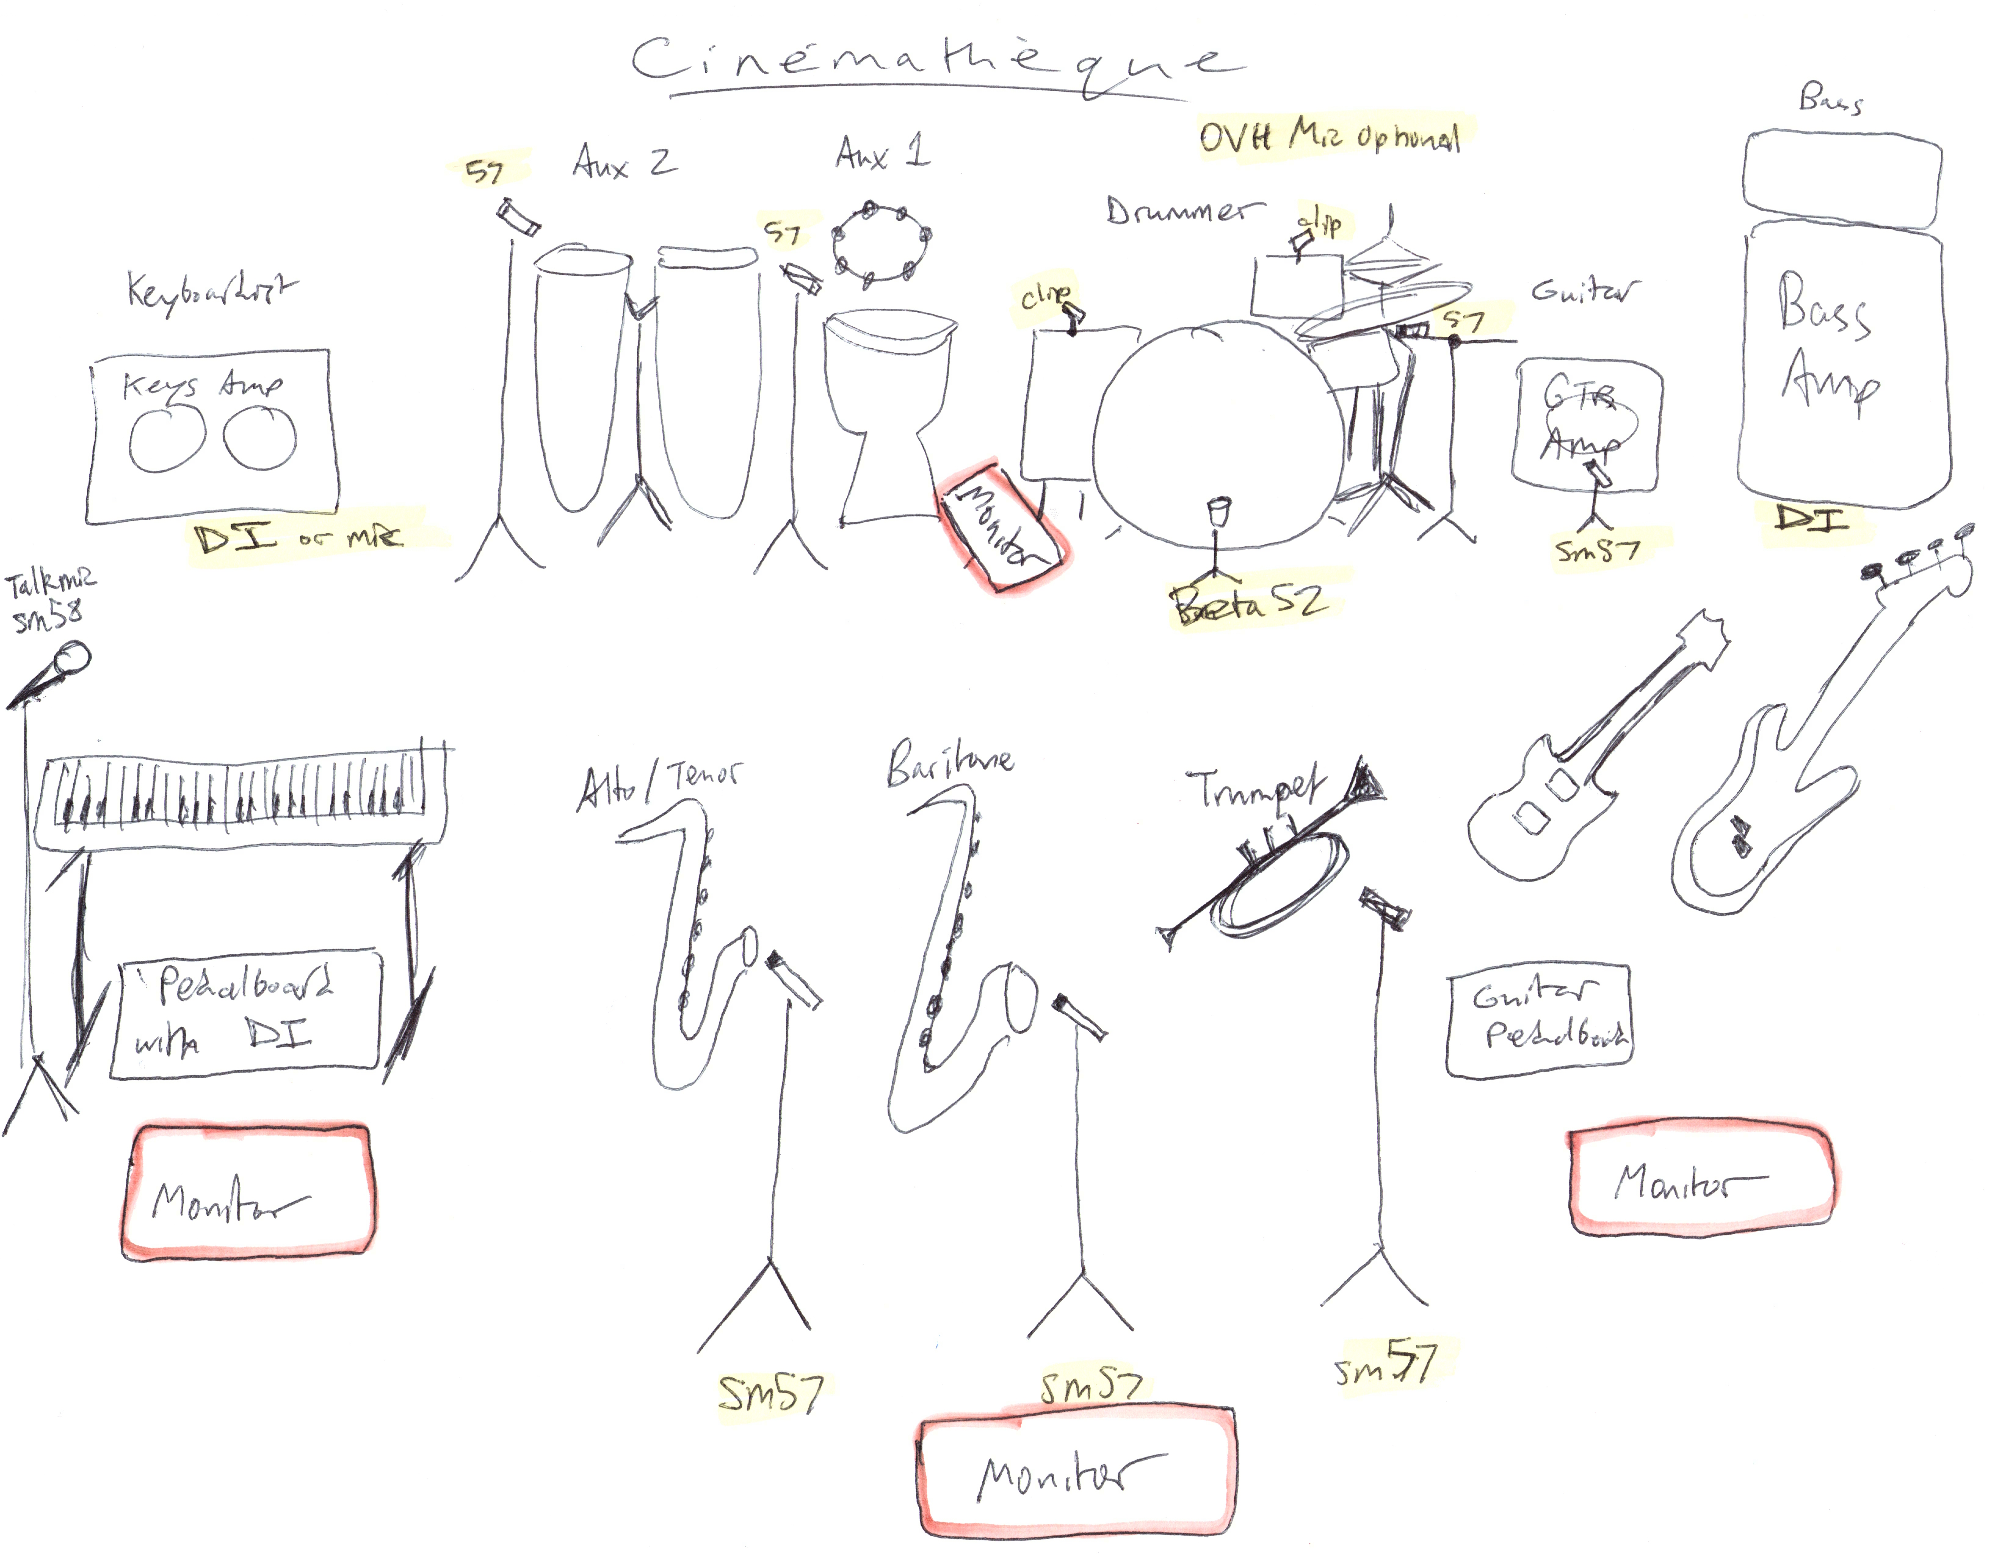
Input List below on Page 2

Cinémathèque Input List
Instrument | Suggested Mic / DI |  | Notes
Horns
1) Trumpet | 57 |  | Doubles as occassional talk mic
2) Baritone Sax | 57 or 421
3) Tenor / Alto Sax | 57 or 421
Drum Kit
4) Kick | 52 |  | 18"
5) Snare | 57 |  | 14"
6) Rack Tom | Dynamic Clip |  | 12"
7) Floor Tom | Dynamic Clip |  | 14"
Guitars / Keys
8) Guitar | 57 |  | Gibson< Pedalboard< Peavey Classic30
9) Keys | DI or 57 |  | Nord< Pedalboard< DI< Roland JC 120
10) Talk Mic for Keys Player | 58
11) Bass Guitar | DI |  | P Bass< Ampeg PF20T
Aux Perc |  |  | KEEP VOLUME LOW
12) 2 Congas, Rotos, Cymbal | 57
13) Shakers, Chimes, Blocks | 57
OPTIONAL FOR OUTDOOR FESTIVAL SETUP:
Mono Drum OVH | Condenser |  | RARELY NEEDED OTHERWISE
*Ask for Exotica influenced playlist for Set Breaks if you would like

